

NCICB

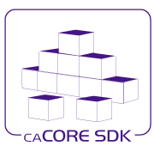
caCORE SDK / CSM
SDK/CSM Implementation Changes for caGRID

Version No: 0.2
Last Modified: 2/26/2006

Author: Satish Patel, Kunal Modi
Team: caCORE SDK/CSM
Client: National Cancer Institute - Center for Bioinformatics,
National Institutes of Health,
US Department of Health and Human Services

This document was prepared for
NCI Center for Bioinformatics, pursuant to the caCORE Software Development Kit (SDK)
Enhancement project.(REF: Solicitation No. S06-234).

Document History

Document Location
The most current version of this document is located in CVS under cacoresdk/Project/SDK v3.2.0.1/Development/Design

Revision History
Version Number | Revision Date | Author | Summary of Changes
0.1 | 2/19/07 | Satish Patel | Initial draft
0.2 | 2/26/07 | Satish Patel, Kunal Modi | Added section 4 and 5

Review
Name | Team/Role | Version | Date Reviewed | Reviewer Comments

Related Documents
More information can be found in the following related documents:

Document Name

Table of Contents
Document History 2
0.1 Document Location 2
0.2 Revision History 2
0.3 Review 2
0.4 Related Documents 2
Table of Contents 3
Table of Figures 5
1. Introduction 6
1.1 Purpose 6
1.2 Intended Audience 6
1.3 Scope 6
1.4 Overview 6
1.5 Definitions, Acronyms, and Abbreviations 6
2. SDK 3.2 Security 7
2.1 Overview 7
2.2 Security implementation in the Java API 7
2.3 Known limitations of current implementation 8
3. Proposed Changes in SDK 3.2 Security for caGRID Compatibility 9
3.1 Known Requirements 9
3.2 Possible approaches to implement the requirements 9
3.3 Dynamic Proxies based implementation 9
3.4 TheadLocal based implementation 9
3.4.1 CORESystem.properties 10
3.4.2 ClientSession 11
3.4.3 Known limitations 11
3.4.4 Additional steps required for caGRID integration 11
3.4.5 List of Files to be Modified 11
4. Security in Thick Client 12
4.1 Known Requirements 12
4.2 Current Implementation of Thick Client 12
4.3 Limitation of Current Implementation 12
4.4 Proposed Approach 13
4.4.1 CORESystem.properties 13
4.5 Limitations of Proposed Approach 14
4.5.1 Additional steps required for caGRID integration 14
4.6 List of Files to be modified 14
5. CSM Enhancements for caGRID Integration 15
5.1 Upgrading the CSM/caGRID Integration Code Base 15
5.2 Integrating the new Installation process for CSM in SDK generated system 15
5.3 Integrating the new Installation process for CSM in the CSM / caGrid Integration 16
5.4 Configurable Authentication and Authorization for an SDK generated System 17
5.5 Changes to the caGrid Tools and Services 18

Table of Figures

Figure 1: Client Application using a Secured API generated with caCORE SDK 7
Figure 2: Client Application using a Secured API generated with caCORE SDK 10
Figure 3: Thick Client Communication in caCORE SDK 12
Figure 4: Thick Client Application using a Secured API generated with caCORE SDK 13

Introduction

Purpose
Purpose of this document is to discuss the implementation of the CSM security in SDK 3.1/3.2 and recommend a technical design that would allow user to configure the security policy such that SDK generated client can be effectively used with caGRID inside the web container when the CSM security is enabled.

Intended Audience
The intended audience for this document includes Developers and Architects interested in the obtaining an overview of security implementation works in the caCORE SDK.

Scope
The scope of this document is limited to a discussion of the current security implementation within the caCORE SDK with one possible way to overcome the limitation. A discussion related to using external APIs and tools is beyond the scope of the document.

Overview
The following sections first provide a brief overview of how the security was initially developed in caCORE SDK. Subsequent to the initial design, it describes the limitation of the current approach and a design is proposed to overcome the known limitations. In the later section, it also provides a list of possible changes and implications on the client to use the new system.
Section 2 of the document describes the current implementation of security in the SDK remote client. In section 3 various approaches to resolve the known problem with remote client security is discussed along with the design specification for one of such approaches. In section 4, implementation of security in Thick client is discussed. Following to that in section 5, CSM security enhancement to support caGRID is discussed with integration steps to be performed by caGRID team.

Definitions, Acronyms, and Abbreviations
All definitions, acronyms, and abbreviations are provided in the centralized definition document found at cacoresdk/Project/SDK v3.2/Miscellaneous/Acronyms.doc.

SDK 3.2 Security

Overview
caCORE SDK generated application can be secured or unsecured depending upon the user’s preference selected at the build time. If the user elects to create a secured application then Common Security Module (CSM) is being leveraged to perform authentication and authorization on the server side. Security in the generated system however is implemented in a proprietary manner. In SDK 3.2, the security was implemented in all the three different interfaces available to access the data. i.e. 1) Web interface 2) web service interface and 3) Java API interface. The web interface and the web service interface are secured using the intercepting filter on the server side. The client is responsible to include the security credentials in URL (in case of web interface) or in the request header (in case of web service). Security implementation in the Java API is being implemented as described in the following subsection.

Security implementation in the Java API
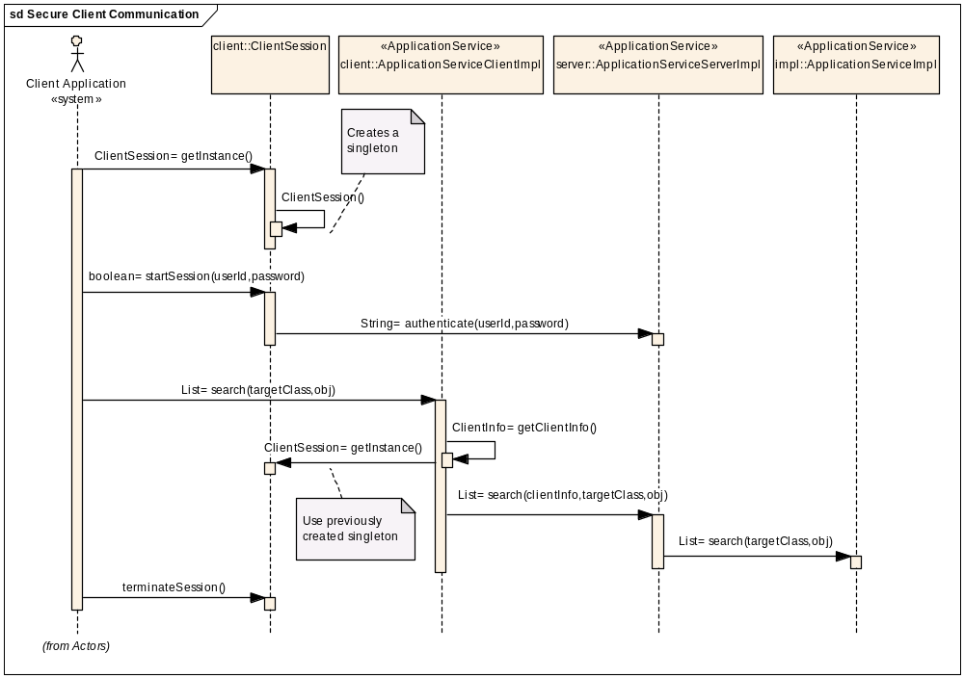

Figure 1: Client Application using a Secured API generated with caCORE SDK
Client of the SDK generated system is required to follow a specific protocol to access data from a secured system. The protocol of accessing data consist of a series of steps as described below
- Initialize ApplicationService (ApplicationServiceProvider. getInstance())
- Start session (ClientSession.startSession(username, password))
- Search and retrieve data (ApplicationService.search(…))
- Terminate session (ClientSession.terminateSession())
Note: Steps 2 and 4 are required only for the secured APIs.

When the client application invokes into the generated API to start the session, the user also passes security credentials (username and the password) to be authenticated against. Upon successful authentication, a client session is initiated (which will be available to all the threads trying to access the application service from the same JVM) and will remain active till the user purposefully terminates it by invoking into API’s terminate session method call. After successful initialization of the session, each method call to the client API (ApplicationServiceClientImpl) obtains the client security session information from client session before sending the request to the server (ApplicationServiceServerImpl). Since the client session information is stored once per JVM, the intercepting class (ApplicationServiceClientImpl) can obtain that information unless it is cleared by the user.
On the server side, ApplicationServiceServerImpl intercepts the method call to the ApplicationService and retrieves the security credentials from the request parameters. The security credentials are then stored in a thread level variable so that underlying layers can access it to determine security information without modifying the method signatures of each and every method.

Known limitations of current implementation
In SDK 3.2, the security was implemented in all the three different interfaces available to access the data. i.e. 1) Web interface 2) Webservices interface and 3) Java API interface. First two interfaces do not have any known problems with multiple users trying to access the data at the same time from the same machine. However, the Java API interface does not allow more than one user to use the system at the same time using the same security credentials. SDK generated Java client API stores the security credentials of the user who accessed the system last. In the event of multiple users trying to access the Java client API at the same time (this will be the case if the generated Java client is being used inside the web application), the system propagates invalid information from the client to the server (i.e. information of the last user of the API and not the current user).

Proposed Changes in SDK 3.2 Security for caGRID Compatibility

Known Requirements
- Allow users to specify the security policy implementation (Global or Per thread)
- Allow concurrent users to access the secured system generated by SDK on caGRID
- Keep the user interface backwards compatible with SDK 3.1/3.2

Possible approaches to implement the requirements
In order for Java beans to connect to the server when user demands for an associated object, caCORE SDK’s Java Beans has to know 1) ApplicationService from where it came (or from where to get the associated objects) and 2) User’s security credentials (ClientSession) which he/she is using to retrieve the data from the server. There are many different ways the Java Bean can learn this information that includes
- Using Singleton design pattern for ClientSession and ApplicationService objects
- Using JNDI for ClientSession and ApplicationService storage
- Store ClientSession and ApplicationService reference inside the Java Bean by using dynamic proxies
- Using singleton per thread (ThreadLocal) for ClientSession and ApplicationService

First two approaches will limit only one user per JVM i.e. only one user can access secured application at a time. caCORE SDK’s current implementation is based on the approach 1 as mentioned in the previous section. Approach 1 and approach 2 are virtually the same approach.
On the other hand, the last two approaches allow concurrent users to access the secured system at the same time. Sections below describe implementation details for the approach 3 and 4.

Dynamic Proxies based implementation
An alternate way to implement the security in SDK generated system would be that the ApplicationService would remember the user who is been using the service to obtain the data from the server. In order to implement such a solution, one can use an option of Dynamic Proxies. CGLIB is a publicly available open source API that allows the user to create a proxy subclass for any concrete object, which is not possible with JDK dynamic proxies. By using CGLIB for implementation, one can ensure that the security information is stored inside the proxy representation of the Java beans being fetched from the server. This stored information can be utilized to fetch associated objects along with proper security credentials. However, implementing this solution would break the backwards compatibility requirement so this solution is not feasible for the current release and can be considered as candidate for the future release.

TheadLocal based implementation
ThreadLocal based implementation will allow the system to store the user’s security credentials in the storage space specific to the current thread under execution. As shown in the sequence diagram below, one needs to store the information in the ThreadLocal variable instead of a local singleton object in order to implement the solution.

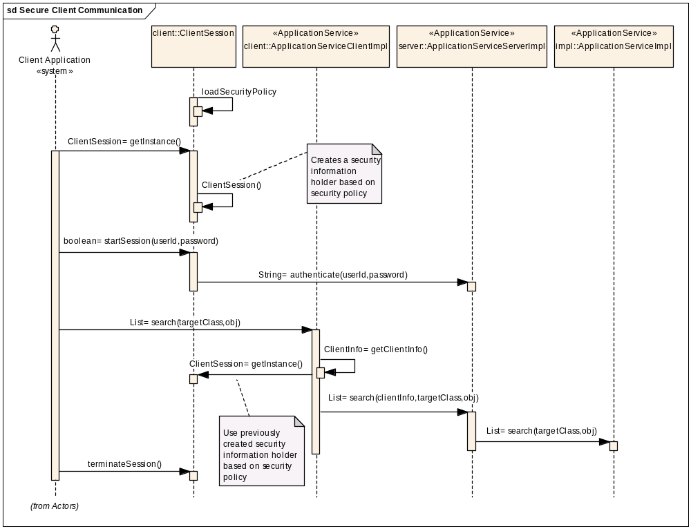
Figure 2: Client Application using a Secured API generated with caCORE SDK

CORESystem.properties
In order to allow the users to specify the security policy implementation externally, configuration information is required to be stored in an external file. CORESystem.properties file holds some of the key properties required by the system at the runtime. An additional property should be defined in this file to indicate the security policy. Suggested values for the property is as below
SECURITY_POLICY=1 (Thread level)
SECURITY_POLICY=2 (Global level)
Thread level security means that the user information will be stored per user thread. Global level security means that the user information will be stored per JVM.
Note:
- If the user decides to use a custom classloader to load the SDK generated system then the Global level security will mean “User per classloader”
- CORESystem.properties file will be loaded only once when ClientSession class is being accessed for the first time by JVM i.e when the class is being loaded.

ClientSession
ClientSession class is the main class that orchestrates the security in coordination with ApplicationServiceClientImpl class. ApplicationServiceClientImpl class accesses getInstance() method of the ClientSession to obtain the current client session. Based on the security policy (Thread or Global), the ClientSession class should return appropriate instance of ClientSession to be used. On the other hand, the ClientSession class should configure itself by reading the CORESystem.properties file to determine security level. In case if the user has specified wrong security level or user has not specified any security level then in that case the ClientSession should default to the Global security level.
If the Global security level is been defined then in that case, the user should always get back the same instance of ClientSession object from any thread it invokes from. This can be achieved by using a Singleton design pattern on ClientSession object. Current implementation of ClientSession works on the Global security level without using the name “Global”.
If Thread based security level is been defined by the user then in that case the ClientSession object should be stored in the stack of current thread under execution. This functionality can be achieved by using a ThreadLocal feature of JDK.

Known limitations
The suggested approach makes sure that the multiple users can access the ApplicationService at the same time from different thread which satisfies the need of caGRID and also keeps the interface of the API to be backwards compatible. However, while doing so, the burden of closing the ClientSession will be on the user of the generated client API i.e. caGRID. If for some reason the user (client program) do not terminate the ClientSession then it will be up to the implementation of the container (which is creating threads in which user is executing the ApplicationService) to clean up the ThreadLocal variable from the stack of the current executing thread before returning that thread to the pool.

Additional steps required for caGRID integration
The CORESystem.properties file is bundled together with the SDK generated client JAR file. In order to configure the Thread level security, the CORESystem.properties file needs to be changed. Following are the steps to change the property file
- Extract the client JAR file in temporary folder
- Open CORESystem.properties file
- If SECURITY_POLICY property exist and it has value anything other than “1” (Thread level) then change it to “1”
- If SECURITY_POLICY property do not exist then add the property with value of “1” (Thread level)
- Close the property file
- Repackage the client JAR fileFiles to be Modified

List of Files to be Modified
File Location | File Name | Purpose
gov.nih.nci.system.comm.client | ClientSession.java | Implement the suggested changes from previous section
conf | CORESystem.properties | Incorporate SECURITY_POLICY property

Security in Thick Client

SDK generated remote client has a limitation with the login mechanism. In the caGRID environment, when the grid service wants to make a secured call to the SDK generated remote service, the grid service invokes into the ClientSession.startSession() method which in turn sends username and password as security credentials to the SDK generated server application. As the grid user’s login information is a grid proxy (which is a publicly available information), the security login is mimicked and can allow external users to login using a spoof grid proxy. In order to resolve the problem, the SDK generated application will have to be deployed as part of the grid service so that the security credentials do not travel across the unsecured environment like SDK generated server application.

Known Requirements
- Allow users to use security in the Thick client generated by caCORE SDK
- Keep the user interface backwards compatible with SDK 3.1/3.2

Current Implementation of Thick Client

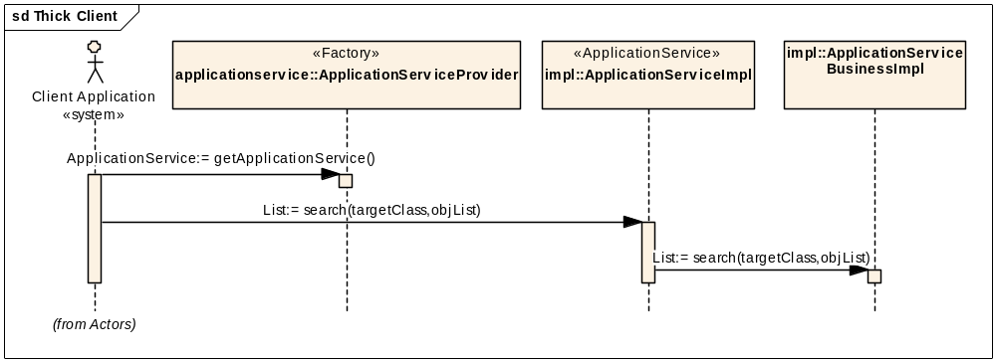
Figure 3: Thick Client Communication in caCORE SDK

In the current implementation, when the client application demands for ApplicationService instance, a local instance (ApplicationServiceImpl) is returned to the client instead of remote instance (ApplicationServiceClientImpl). ApplicationServiceImpl class is a child class of ApplicationService which implements all the abstract methods for search operations.

Limitation of Current Implementation
As mentioned in the previous section, the client performs a login on the ClientSession which in turn invokes into the ApplicationServiceServerImpl and creates a new UserSession on the SDK generated server application. As the thick client is embedded within the user application, it does not have ApplicationServiceServerImpl, ApplicationServiceClientImpl and ClientSession classes. As a result, the client application is not able to log in to the application and a secured operation cannot be performed.

Proposed Approach
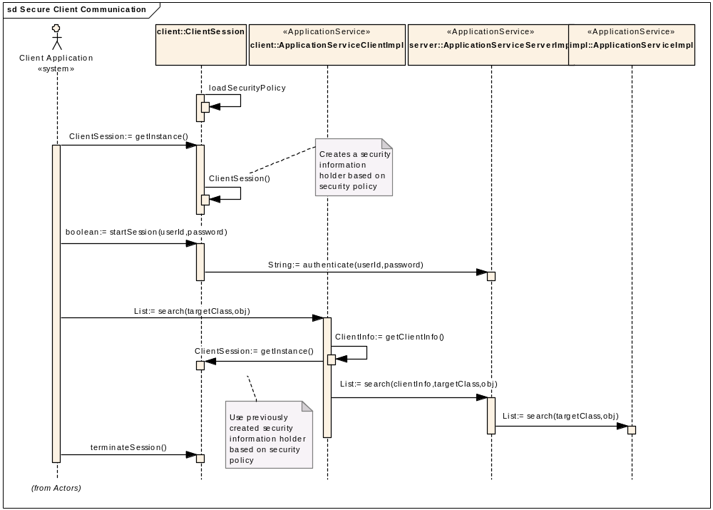
Figure 4: Thick Client Application using a Secured API generated with caCORE SDK

The sequence diagram shown above describes the behavior of the Thick client API generated by caCORE SDK. The sequence diagram looks identical to the sequence diagram for the remote client. In the remote client when the ApplicationServiceClientImpl wanted to send information across to the ApplicationServiceServerImpl, Spring framework was being used to leveraged to handle remoting component. In the proposed design, instead of using the remoting component, the ApplicationServiceClientImpl class will be able to get a direct reference to the ApplicationServiceServerImpl from the local classpath. Once the remote communication component is bridged locally, rest of the application will work in identical manor to the remote client server communication.

CORESystem.properties
In order to allow the users to specify the client implementation externally, configuration information is required to be stored in an external file. CORESystem.properties file holds some of the key properties required by the system at the runtime. An additional property should be defined in this file to indicate the client implementation. Suggested values for the property is as below
CLIENT_TYPE=1 (Remote Client)
CLIENT_TYPE=2 (Thick Client)

Limitations of Proposed Approach
The proposed implementation keeps all the communication layers in the system to maintain the existing workflow, which is unnecessary. Since the communication layers do not add any additional overhead other than passing information to the next layer in the sequence, proposed approach’s limitation can be ignored.

Additional steps required for caGRID integration
When the user of the grid service is trying to create the grid service, he should be prompted for remote client vs thick client. If the user is using the thick client then following items should be considered for grid service deployment
  - Thick client required additional JAR files which are kept under the lib directory of thick client generated
  - If user has specified JNDI datasource in the database configuration with Hibernate then users should be prompted for a) datasource configuration with container and 2) putting proper driver file in the container’s shared library.

List of Files to be modified
File Location | File Name | Purpose
gov.nih.nci.system.applicationService | ApplicationServiceProvider.java | Always return ApplicationServiceClientImpl class for ApplicationService for thick client
gov.nih.nci.system.comm.client | ClientSession.java | Get reference to local vs remote ApplicationServiceServerImpl
 | ApplicationServiceClientImpl.java | Get reference to local vs remote ApplicationServiceServerImpl
gov.nih.nci.system.comm.server | ApplicationServiceServerImpl.java | Always get instance of ApplicationServiceImpl.java
conf | CORESystem.properties | Incorporate THICK_CLIENT property

CSM Enhancements for caGRID Integration

The CSM caGrid Integration currently uses a beta release of CSM v3.2. Also they do not leverage the new capabilities provided by CSM v3.2 like the new integration and installation procedure or the enhanced exception handling capabilities. However to integrate the latest 3.2, minor modification would be needed to support overriding of the manager (as done by the caGrid team) using the new installation procedure
The following pertain to requirements deemed necessary for upgrading the CSM / SDK as well as the CSM / caGrid Integration to use new functionalities provided in CSM v3.2

Upgrading the CSM/caGRID Integration Code Base
Currently the CSM / caGrid Integration uses a beta version of the CSM v3.2 release. There have been many new features added to the CSM v3.2 after this beta version. These new features cannot be leveraged by the caGrid client. Hence in order to provide these the CSM / caGrid integration would be updated to use the latest version of CSM.
The CSMGridAuthorizationManager class from the caGrid Authz project would need to be upgraded to implement the new Authentication and Authorization Manager of CSM v3.2. In order to do so, the CSM API library jars would be upgraded along with the necessary supporting jars. However to be in sync, even the caCORE SDK project would be upgraded to use the exact version of CSM APIs.

Integrating the new Installation process for CSM in SDK generated system
Currently the in a CSM enabled SDK generated system users need to configure CSM externally after they have generated the system. This is cumbersome and error prone. Also it requires users to read a separate guide for CSM apart from the SDK Guide.
In order to facilitate ease of installation of a CSM enabled SDK generated system we need to leverage the new features provided by the underlying CSM v3.2. For this the following changes will be made to an SDK generated system.
- SDK’s deploy.properties file will now have additional parameters for the user to specify the database connection parameters for the CSM Authorization Schema. Following are the new entries
  - csm.database.url – This is the jdbc url for the CSM Authorization Schema
  - csm.database.username – This is the user name to used to connect to the database
  - csm.database.password – This is the password to used along with the user name for connecting to the database
  - csm.database.driver – This is the database driver used for connecting to the database
  - csm.hibernate.dialect – This is the hibernate dialect class which needs to be used to communicate with the database
- SDK will now have a new ant task which will create a hibernate configuration file which points to the CSM Authorization Schema if the user’s have enabled CSM Security. This task will create a new hibernate cfg file using the CSM application context name provided in the deploy.properties from a pre-created template. The file name will follow the following convention for the CSM APIs to recognize it and use it for connecting to the database
  - <<Application Context Name>>.csm.new.hibernate.cfg.xml
Also this task will replace the place holders for the database parameters with the one supplied above in step 1. This file will then be placed in the classpath in the WEB-INF/classes folder of the SDK generated server web application (war file). The CSM APIs will recognize the file and use it directly to connect to the Authorization Database.
Also this task will replace the place holders for the database parameters with the one supplied above in step 1.

- This ant task will also create an Application Security Config with an entry for the application using the Application Context Name provided. This will be a blank entry which will later be used by the caGrid Integration to supply their implementation of the CSM Authorization Manager. This file will also be placed in the classpath in the WEB-INF/classes folder of the SDK generated server web application (war file).

- This eliminates the need for the users to
  - Make an entry in the properties file to point to the Application Security Config file
  - To create the Application Security Config file itself with the entry for the application and pointer to the hibernate config file.
  - To create the external hibernate config file to point to the database.
Note: This process just eliminates the need to configure Authorization externally. Users still need to provide a JAAS entry for the purpose of CSM Authentication to work.

Integrating the new Installation process for CSM in the CSM / caGrid Integration

With the above mentioned CSM SDK Integration in placed we can now leverage the CSM’s easy installation steps while creating a grid node for a CSM SDK generated system. This eliminates the need for configuring an external Application Security Config file as mentioned above in last step.
However the caGrid Integration their own implementation of the Authorization Manager which they specify using the Application. They have overridden certain methods of the CSM’s AuthorizationManager to invoke GridGrouper for obtaining the user’s group and it purpose of Authorization.
So if we want to provide easier way of configuring the CSM enabled SDK generated web application, then we need to modify CSM to allow overriding of both the Authentication and Authorization Managers in the new configuration.
Following are the changes which would be made to the CSM APIs
- CSM Security Service Provider will be modified to accept the Application Security Config file from class path as well.
- It will try to read the Authorization Class implementation for the Application from the Application Security Config File. If it finds it, it would use that implementation else it would just use the default implementation provided by CSM.
- It would then proceed to load the hibernate configuration from the classpath as per the new installation procedure happening in CSM v3.2

The caGrid Integration will need to perform the following steps to over ride the default implementation of the CSM make an entry in Application Security Config file to provide their implementation of the CSM’s AuthorizationManager Class.
- It would need to explode the SDK’s generated war file and open the Application Security Config file from the WEB-INF/classes folder.
- It would need to make an entry in this for the CSMGridAuthorizationManager as shown below
<security-config>
<upt-context-name>
</upt-context-name>
<application-list>
<application>
<context-name>
ABC_APP
</context-name>
<authentication>
<authentication-provider-class>
</authentication-provider-class>
<lockout-time>
</lockout-time>
<allowed-login-time>
</allowed-login-time>
<allowed-attempts>
</allowed-attempts>
</authentication>
<authorization>
<authorization-provider-class>
gov.nih.nci.cagrid.authorization.impl.CSMGridAuthorizationManager
</authorization-provider-class>
<hibernate-config-file>
</hibernate-config-file>
</authorization>
</application>
</application-list>
</security-config>

- Repackage the war with the above changed file and deploy the same. Now whenever the application invokes CSM it would use the Grid Implementation of the Authorization Manager as desired.

Configurable Authentication and Authorization for an SDK generated System
Currently whenever you enable security in an SDK generated system it turn on both the Authentication as well Authorization services. This requires the user to first provide credentials to be authenticated and then only a session is initiated for him. Once a session is established the user can perform multiple query requests over this session. The user token associated with the session is used to determine whether the user has permissions to perform that particular operation or access that particular resource.
However in case of a grid node the authentication is performed by the under lying grid security framework (GAARDS). Hence whenever the user is trying to access data via the SDK generated client or thick client, he is already validated for his authenticity using his grid credentials. Currently both CSM and CSM enabled SDK generated system do not posses the capabilities to validate the grid credentials due to the following reasons:
- The are not part of the grid trust fabric as the result they cannot validate the grid proxy certificate
- The user’s private key is not available for signing. As a result the authentication mechanism cannot be guaranteed, as it would be based on user’s public information like his grid proxy certificate or grid identity.
To overcome the need for Authentication, currently the caGrid integration team had overridden the authentication service to just validate the user using his grid identity and the service URL as user name and password. Again this was not optimum as both of these credentials are public information and a informed user can easily provide these from other clients for the same SDK generated system and obtain entry into the system.

So to over come these shortcomings the following changes are proposed.
- The caGrid Introduce tool will now use an SDK generated thick client in order to generate a data service node.
- The CSM integration in SDK will be made configurable to allow either of the security services to be used. So based on the configuration settings user can select either authentication or authorization services or both.
- When the authentication service is turned off, CSM will generate a user session token without authenticating the user.
- All these configuration will be made part of an external configuration file (CORESystem.properties) to allow modifications without need to regenerate the code.

Changes to the caGrid Tools and Services
Based on the changes mentioned above, the caGrid Team would be needed to perform the following changes:
- Upgrading the GridCSMAuthorizationManager to the latest CSM v3.2 Interfaces and also to remove the current Authentication Mechanism using the grid identity and the service URL
- Repacking of the SDK generated thick client / server component to override CSM’s default AuthorizationManager with GridCSMAuthorizationManager in the ApplicationSecurityConfig file

